**Why are supernovas super?**

***Aarav Bhardwaj***

Introduction: Have you ever wondered Why do we exist, Why the Big Bang occurred. Well, this question can be answered by tiny particles Neutrinos.

Neutrinos: Neutrinos are formed during the nuclear fusion inside the core of the stars. Hydrogen atoms fuse and form Helium and release photons of light and neutrinos. Trillions of neutrinos shoot out of core and pass through planets, stars etc. Fun thing is that if they pass through earth we will not feel a single too. It is hard to detect neutrinos but it’s not impossible we can detect those through the collisions with the atoms of Earth. So, underground neutrino detectors were built but only 1/3rd of neutrinos were detected this was called the solar neutrino problem. This was because neutrinos could change their identity. When the neutrino changed their identities, it is called **Flavor changing**.

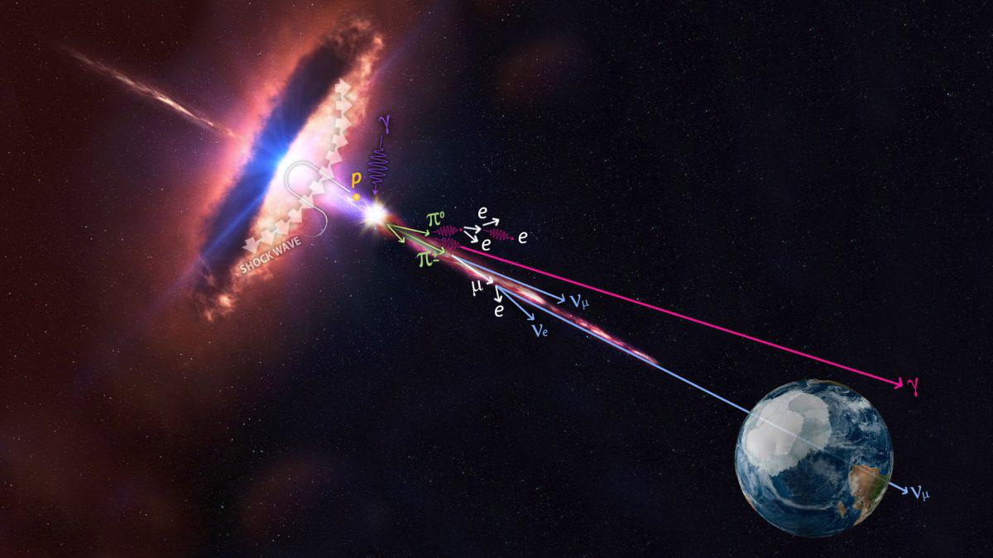

Types of Neutrinos: There are 3 types of neutrino-:

1]. Electron Neutrino

2]. Muon Neutrino

3]. Tau Neutrino

Hypothesis Neutrino

Sterile Neutrino: This is a hypothesis. We don’t know whether it exist or not.

By the time they reach Earth they change flavor. Neutrinos have very little mass because they can change flavor. This means that they can not travel at the speed of light. Detectors such as Ice Cube Neutrino Observatory built at South Pole station in Antarctica. In July 2018, the Ice Cube Neutrino Observatory announced that they have traced an extremely-high-energy neutrino that hit their detector on September 2017 that neutrino came from  [blazar](https://en.wikipedia.org/wiki/Blazar) [TXS 0506 +056](https://en.wikipedia.org/wiki/TXS_0506_%2B056) located 5.7 billion [light-years](https://en.wikipedia.org/wiki/Light-year) away in the direction of the constellation [Orion](https://en.wikipedia.org/wiki/Orion_(constellation)).

Don’t judge by Size: When a star run out of fuel, It’s core crushes to a neutron star. It collapses in wards, then hits the neutron star and bounces out triggering a supernova. But computer model says that after this bounce the explosion doesn’t trigger that way how a supernova should. It needs another source of energy to propel it. The source of energy is – neutrinos. When the neutrino passes through a dying star and it is flying out of the core region, a very tiny fraction of them interact with the gas and it produces heat. The heat creates pressure in the surrounding gas, it builds and build until it triggers. Without neutrinos supernovas aren’t so super. We might not exist either without neutrinos as Neutrinos kindle the fire. We don’t have elements without neutrinos, without element we don’t have planet, stars etc., without planets we don’t have life.

Conclusion: Neutrinos are tiny particles having very little mass. There are mainly 3 types of Neutrinos-Electron, Muon, Tau Neutrino. There is one more type of neutrino- Sterile Neutrino but we do not know that they exist. Neutrino can almost travel in the speed of light. They are the reason why supernovas are super, they also are the reason why we exist. We can consider neutrinos one of our relatives. So, whenever you’re sad, say thanks to God and Neutrinos for giving you this life.

